Lab 3 - Routing Protocol

NAME: ABDURRAFIQ BIN ZAKARIA
MATRIC NUM.: A24CS0031
SECTION: 05
INTRODUCTION
This lab looks into the network layer, focusing on subnetting and routing.

TOPOLOGY

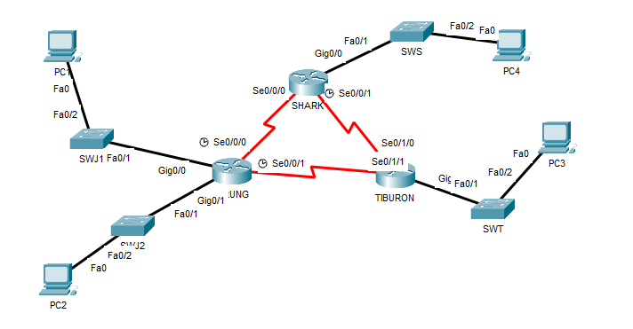

LAB INFORMATION
Here is some basic information for the lab. The network address given is 172.18.110.0/23.
Table 1

Device | Subnetwork | Usable Hosts
JERUNG | LAN1 | 20
JERUNG | LAN2 | 30
SHARK | LAN | 60
TIBURON | LAN | 50
Connections | JERUNG-SHARK | 2
Connections | JERUNG-TIBURON | 2
Connections | SHARK-TIBURON | 2

Table 2

# | Device  Name | Interface | IP Address | Subnet Mask | Gateway
1 | JERUNG | Se0/0/0 | 172.18.110.193 | 255.255.255.252
2 | JERUNG | Se0/0/1 | 172.18.110.197 | 255.255.255.252
3 | JERUNG | G0/0 | 172.18.110.161 | 255.255.255.224
4 | JERUNG | G0/1 | 172.18.110.129 | 255.255.255.224
5 | TIBURON | Se0/1/1 | 172.18.110.198 | 255.255.255.252
6 | TIBURON | Se0/1/0 | 172.18.110.201 | 255.255.255.252
7 | TIBURON | G0/0 | 172.18.110.65 | 255.255.255.192
8 | SHARK | Se0/0/0 | 172.18.110.194 | 255.255.255.252
9 | SHARK | Se0/0/1 | 172.18.110.201 | 255.255.255.252
10 | SHARK | G0/0 | 172.18.110.1 | 255.255.255.192
11 | PC1 | - | 172.18.110.190 | 255.255.255.224 | 172.18.110.161
12 | PC2 | - | 172.18.110.158 | 255.255.255.224 | 172.18.110.129
13 | PC3 | - | 172.18.110.126 | 255.255.255.192 | 172.18.110.65
14 | PC4 | - | 172.18.110.62 | 255.255.255.192 | 172.18.110.1

Calculation Workflow
- Rank by Size: List all subnets from the largest host requirement to the smallest.
- Identify Network Portion: Use the CIDR (e.g., /20) to identify where the network portion ends and the host portion begins.
- Find the Power of 2 (n): Find 2^{n} - 2 that fits the number of devices. This n tells you how many bits to take from the right for the host portion.
- Set Boundaries:
  - Network Address: Set all n host bits to 0.
  - Broadcast Address: Set all n host bits to 1.
  - Usable Range: All numbers between the network and broadcast addresses.
- Proceed: Add 1 to the current broadcast address to find the starting point for the next subnet.

Calculations:
Step 1: Ranking by Size
- SHARK LAN: 60 Hosts
- TIBURON LAN: 50 Hosts
- JERUNG LAN2: 30 Hosts
- JERUNG LAN1: 20 Hosts
- WAN Links: 2 Hosts each
Step 2: Individual Subnet Calculations
- SHARK LAN (60 Hosts)
  - Power: 2⁶ – 2 = 62 (Fits 60 Hosts)
  - Prefix: 32 – 6 = /26
  - Subnet Mask: 255.255.255.192
  - Range: start at 172.18.110.0
  - IP Address: First usable is 172.18.110.1
  - PC4: Last usable is 172.18.110.62
  - Next Subnet Start: .63 (Broadcast) + 1 = .64

- TIBURON LAN (50 Hosts)
  - Power: 2⁶ – 2 = 62 (Fits 50 Hosts)
  - Prefix: 32 – 6 = /26
  - Subnet Mask: 255.255.255.192
  - Range: start at 172.18.110.0
  - IP Address: First usable after .64 is 172.18.110.65
  - PC3: Last usable is 172.18.110.126
  - Next Subnet Start: .127 (Broadcast) + 1 = .128
- JERUNG LAN2 (30 Hosts)
  - Power: 2⁵ – 2 = 30 (Fits 30 Hosts)
  - Prefix: 32 – 5 = /27
  - Subnet Mask: 255.255.255.224
  - Range: start at 172.18.110.0
  - IP Address: First usable after .128 is 172.18.110.129
  - PC2: Last usable is 172.18.110.158
  - Next Subnet Start: .159 (Broadcast) + 1 = .160

- JERUNG LAN1 (20 Hosts)
  - Power: 2⁵ – 2 = 30 (Fits 20 Hosts)
  - Prefix: 32 – 5 = /27
  - Subnet Mask: 255.255.255.224
  - Range: start at 172.18.110.0
  - IP Address: First usable after .160 is 172.18.110.161
  - PC1: Last usable is 172.18.110.190
  - Next Subnet Start: .191 (Broadcast) + 1 = .192

- WAN Links (2 Hosts each)
WAN links use a /30 prefix (255.255.255.252).
  - JERUNG-SHARK:
    - Subnet .192/30. First IP is .193; second (SHARK) is 172.18.110.194.
  - JERUNG-TIBURON:
    - Subnet .196/30. First IP is .197; second (TIBURON) is 172.18.110.198.
  - SHARK-TIBURON:
    - Subnet .200/30. First IP (SHARK) is .201; second (TIBURON) is 172.18.110.201.

LAB TASKS

Task 1 – IP Addressing
- Given the network address of the organisation and the basic information provided in both Tables 1 and 2. Show your workings here and complete Table 2 with the correct information. PCs will be given the last usable address of the subnetwork.
- Using the IP addresses calculated, configure the devices with the appropriate information.

Task 2 – Routing Table
- Paste the current routing table of each router here. There are 2 ways to this – via CLI and via Packet Tracer (PT) tool. Use both ways to show the routing table of all the routers.
  - CLI
    - Click on a router. In the prompt, type show ip route. The routing table of the router will be shown, as shown in Figure A.
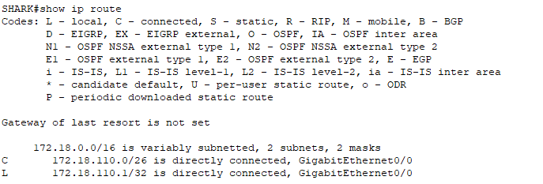
Figure A

SHARK
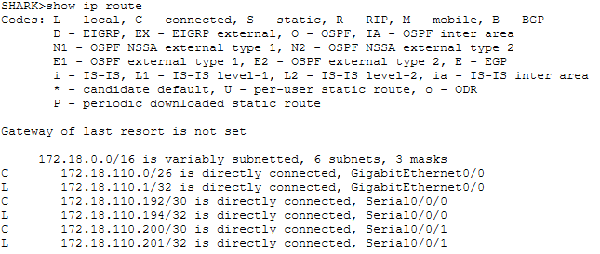

TIBURON
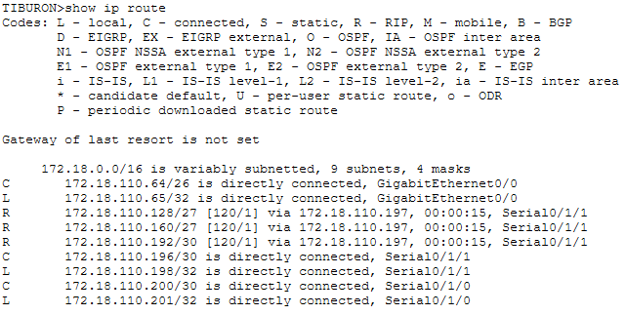

JERUNG 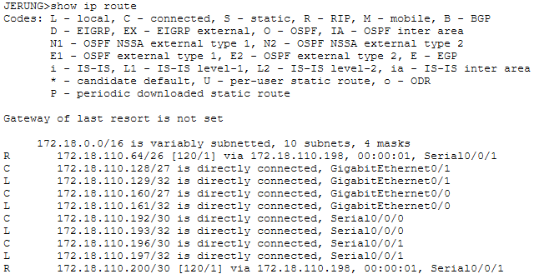
  - PT tool
    - Click on the magnifying glass (shown in Figure B), then click on a router, then choose Routing Table. A sample of the result is shown in Figure C.
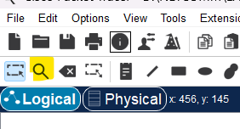
Figure B
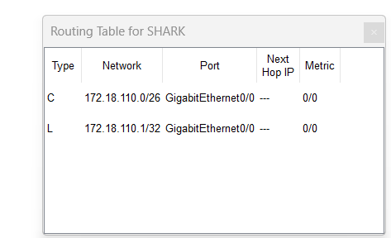
Figure C
SHARK
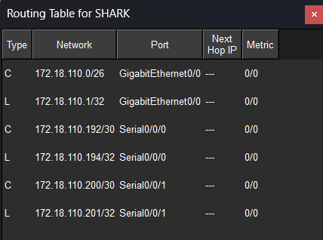

TIBURON
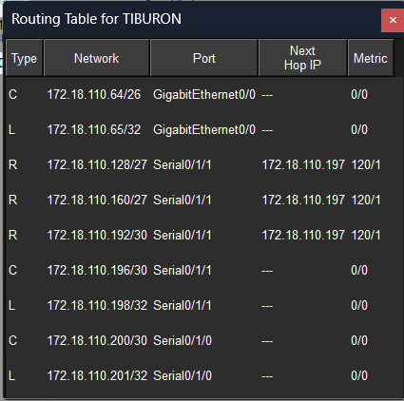

JERUNG
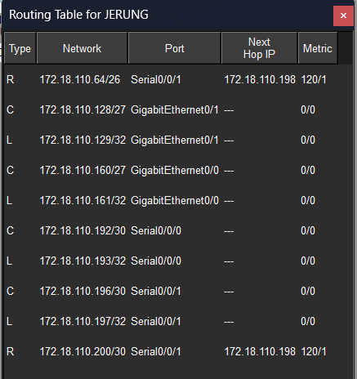
- Try to ping PC2 from PC1, paste the results here.
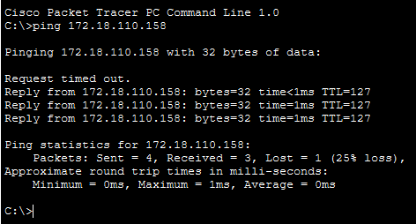
- Try to ping PC4 from PC1, paste the results here.
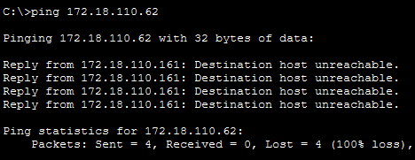
- Explain the reason(s) behind the results.
  - The pings are failing because the routers do not have a full "map" of the network. Currently, each router only knows about the networks it is physically plugged into. It doesn't know where to send data meant for the other side of the lab.

- What needs to be done to ensure all PCs can ping each other successfully?
  - You need to configure Routing (specifically the RIP protocol shown in Task 2). This allows the routers to "talk" to each other and share information about their connected networks so they can find the correct path to every PC.

Task 2 – Routing Configuration
- Let’s start by opening the routing table (using the PT tool) for TIBURON and JERUNG. This is done to show changes to the routing table as configurations are made.
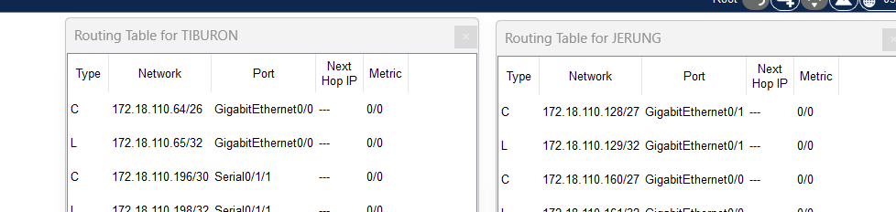
Figure D
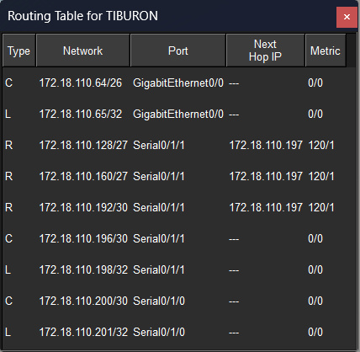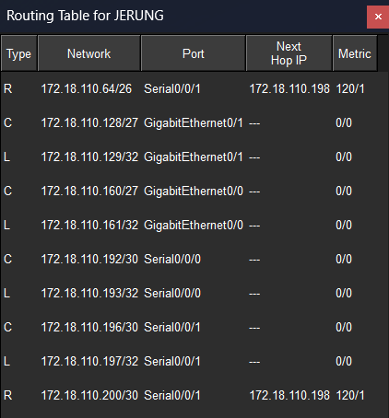
- In router JERUNG, configure the RIP routing protocol as shown in Figure E.
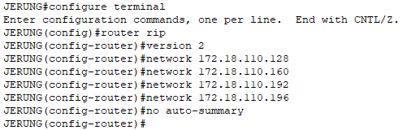
Figure E
  - What can you say about the addresses used in the ‘network’ instructions in Figure E?
The addresses in Figure E are specific subnet addresses rather than the standard "major" classful addresses usually seen in RIP. Since they all belong to the same Class B family (172.18.0.0), you can list them individually like this because you’ve enabled Version 2 and used the no auto-summary command. This tells the router to treat each small segment as its own unique path instead of bunching them all together, which is exactly what’s needed for the different groups of usable hosts in your topology to communicate.
- Then configure RIP in TIBURON. All are similar except use the network address. Use the instructions as shown below.
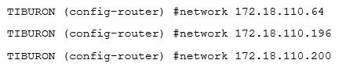
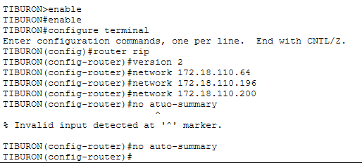
- As you may have seen, there are changes in the routing tables of both TIBURON and JERUNG. Paste a copy of these routing tables here.
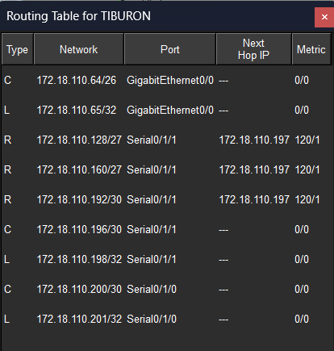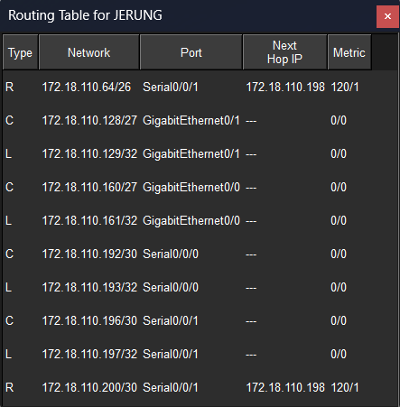

  - What are the changes seen in TIBURON?
    - After configuring RIP, the TIBURON routing table expanded from showing only directly connected networks to including remote networks learned from its neighbors, marked with the code "R". Specifically, it added routes for the 172.18.110.128/27, 172.18.110.160/27, and 172.18.110.192/30 subnets, all pointing to 172.18.110.197 as the next-hop address. This indicates that TIBURON now has full reachability to the networks attached to the JERUNG router, with a hop count (metric) of 1.

  - What are the Networks with type R in TIBURON and JERUNG?
    - TIBURON:
      - 172.18.110.128/27 (via 172.18.110.197)
      - 172.18.110.160/27 (via 172.18.110.197)
      - 172.18.110.192/30 (via 172.18.110.197)
    - JERUNG:
      - 172.18.110.64/26 (via 172.18.110.198)
      - 172.18.110.200/30 (via 172.18.110.198)

  - Ping PC3 from PC1. Was it successful?
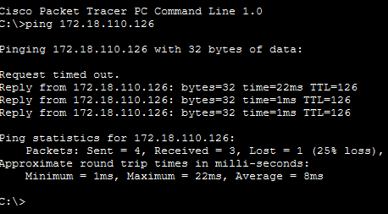
Successfull but still have 25% loss of packets
  - Ping PC4 from PC1. Was it successful?
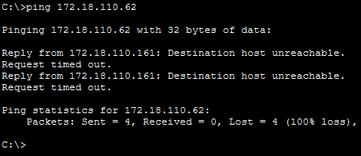
Unsuccessful
  - Explain the reasons for your answer.
The ping from PC1 to PC3 is successful (with 25% loss) because RIP is configured on both JERUNG and TIBURON, allowing them to share the necessary route information. However, the ping to PC4 is unsuccessful (100% loss) because the SHARK router has not yet been configured with RIP. Without this configuration, the other routers lack a path to PC4's network in their routing tables, leaving the destination unreachable.
  - Continue with configuration of RIP in SHARK. Paste your configurations here.
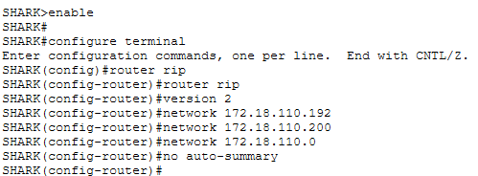
  - Open router SHARK’s routing table and paste here.
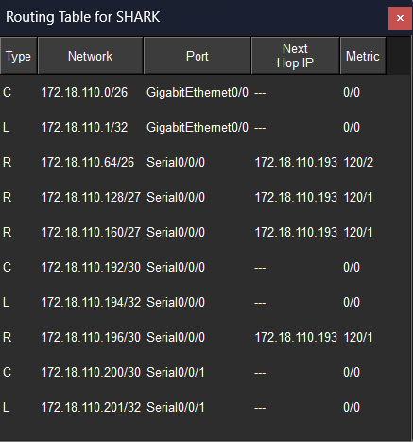
  - Try to ping from PC4 to all other PCs in the topology. *Note: Try to ping at least twice to get best results.
PC | Ping result
1 | 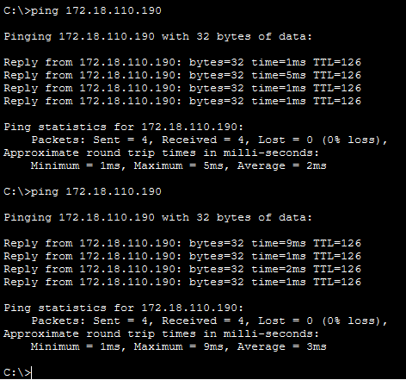
2 | 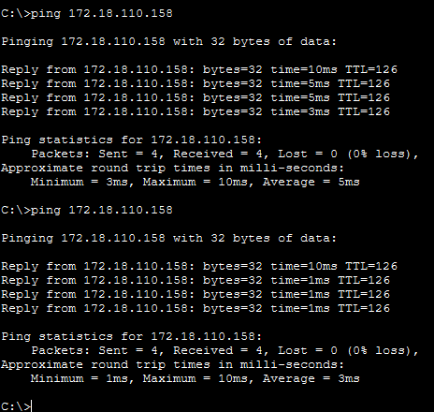
3 | 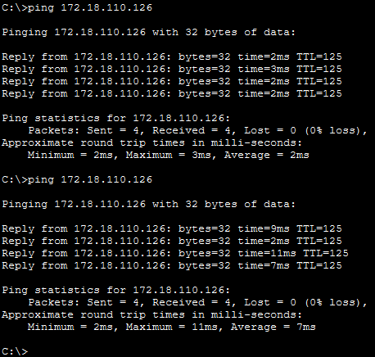

Task 3 – Routing Update
- Let’s try a little experiment. Change the IP addresses of router TIBURON interface G0/0 to 192.168.1.1/24.
  - This means that the subnet has changed. Find the new Network address of this subnet. Network Address is: 192.168.1.1
  - As this change happens, PC3 must also have different IP address, subnet mask and gateway address. What will it be?
PC3 | Info
IP address | 192.168.1.3
Subnet Mask | 255.255.255.0
Gateway Address | 192.168.1.1

  - After this change, can PC4 and PC1 ping PC3?
No, PC4 and PC1 can not ping to PC3 because router SHARK and JERUNG can not know the route to ping to PC3 because of different routing information with router TIBURON.
  - Copy and paste the routing tables for both SHARK and TIBURON here.
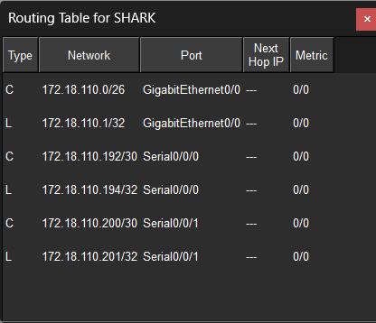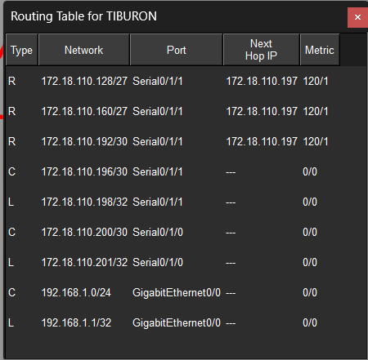
  - Referring to the routing table, explain your findings.
The new address was set up inside router TIBURON which is 192.168.1.0/24 and 192.168.1.1 both use GigabitEthernet0/0 which is not been set up in router SHARK. So, when pinging the PC 1 and PC 4 to PC3, it says "Destination host unreachable" because router SHARK did not know the way to go to PC 3 yet.

  - What is your next move to ensure end-to-end connectivity (i.e. all PCs can ping each other successfully)?
I will update the routing tables of router SHARK and router JERUNG by adding static route for new network 192.168.1.0/24 on these routers so they know to forward traffic towards router TIBURON.

  - Show your configurations in TIBURON to ensure end-to-end connectivity.
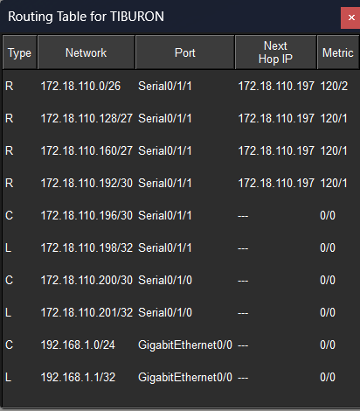

  - To ensure end-to-end connectivity, ping to all the PCs from PC3.
PC | Ping result
1 | 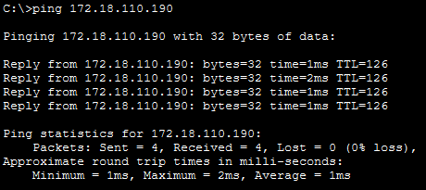
2 | 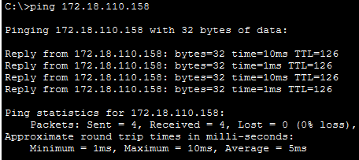
4 | 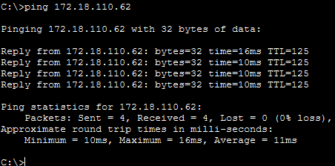

REFLECTION
What have you learned in this task?

Precision in Subnetting and Planning Lab 3 has significantly enhanced my technical understanding of IP addressing and network planning. One of the most important skills I acquired was learning how to identify precise network addresses by calculating "magic numbers" or multiples based on specific subnet masks like .192, .224, and .252. This method was essential for configuring the RIP network commands correctly, as it ensured each interface was mapped to its rightful subnet. Mastering this mathematical logic allowed me to build a more organized and efficient network structure, ensuring that all routers were synchronized within the correct boundaries.

Troubleshooting and Critical Thinking Beyond the initial configuration, this lab truly challenged my critical thinking through troubleshooting and error resolution. Encountering connectivity issues forced me to go beyond the lab manual; I had to conduct extensive research and systematically analyze routing tables to identify the root cause of failures. This process of fixing errors was demanding, yet it taught me how to be a more resilient and resourceful network administrator. Ultimately, successfully resolving these challenges and achieving a successful ping test across the entire topology solidified my confidence in managing real-world network applications.

